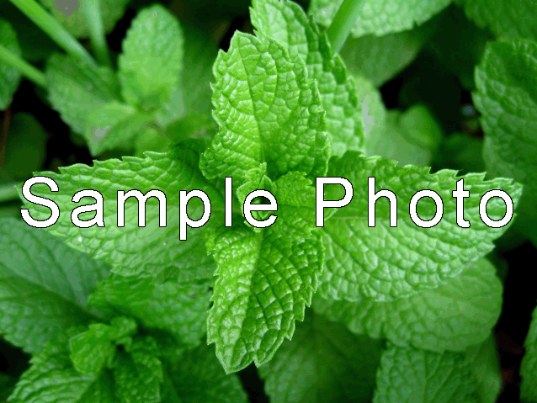

______________
(Latin________________________)
Annual Perennial
Approx time to:
Germination ~_____ days
Transplant after ~_____ weeks
Maturity ~_ weeks

Collected By: ____________________
Location: _________: Elev: _____,
Lat _____________, Lon _____________

Collection Date: _____________

NOTES
Ph pref: ________
Sowing depth: ________
Distance apart: ________
Plant height: ________
Sun needs: ______________________
Water needs: ______________________
Other Info:
___________________________________
___________________________________
___________________________________
___________________________________
__________________________
________________________
_______________________
_____________________

